SUMMARY REPORT OF SEMINAR ON “ Mental Health Awarness” under “ National Mental Health Programme” by Dr. Nirav Chudasama, MD Psychiatric, Padmakurarba Government Hospital, Rajkot.

Eminanat speaker Dr. Nirav Chudasama, delivered a speech on“Mental Health Awareness” under “ National Mental Health Programme” on 6th February, 2020 for the students 6th Semester BPT, School of Physiotherapy (SOPT), RK University.

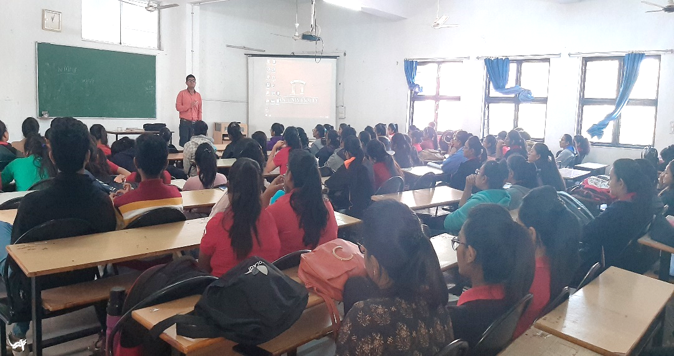

Speech was emphasis more on Importance of Mental Health.
- Awareness about mental disorders,
- How to understand patient’s psychology,
- Choice of treatment for Mental Disorders etc.

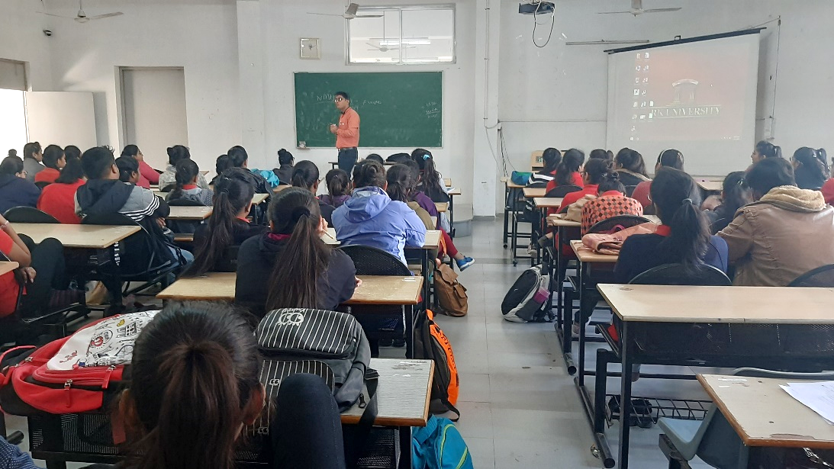

The lecture has proven to be very inspiring and informative for students.

