Summary Report on
Organ Donation Awareness Programme on 14th February,2020

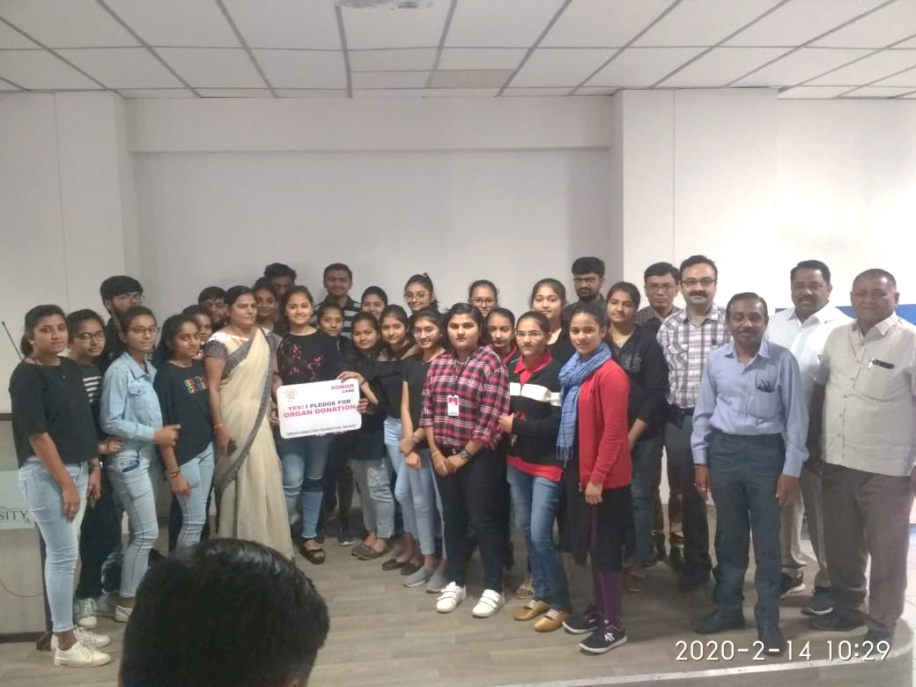

School of Physiotherapy invited Members of Organ Donation Foundation for Organ Donation Awareness Programme on 14th February, 2020 to spread awareness about an organ donation among students. 200 students have participated in the programme from 1st and 6th Semester BPT and 3rd Semester MRIT.

Proceeding of the day was as follows:

TIME | EVENT
8:45 to 9:00 AM | Welcoming of All Members of Organ Donation Foundation by Faculties of SPT
9:00 to 9:05 AM | Social Awareness about Organ Donation by Mansukh Bhai Talsaniya
9:05 to 9:30 AM | Expert session on an Importance of an Organ Donation by Dr. Divyesh Viroja (Nephron Surgeon at B.T. Savani Kidney Hospital Rajkot)
9:30 to 10:00 AM | Expert session on When to Do Organ Donation by Dr. Sankalp Vanzara (Critical Care Surgeon at B.T. Savani Kidney Hospital Rajkot)
10:00 to 10:10 AM | Video Clipping of organ donor Late Radhika’s Life
10:10 to 10:15 AM | Vote of Thank to SPT, RK University by Dr. Pradeep Kansagra (Trustee of B.T. Savani Kidney Hospital, Rajkot
10:15 to 10:30 AM | Facilitation of an Organ donor Ravindrabhai Bosamiya and his wife Jyotsanaben Bosamiya by Bhavnaben Mandali (Member of Organ Donation Foundation)
10:30 to 10:35 AM | Students take pledge for organ donation by Mansukhbahi Talsaniya

Co-ordinator of the: Dr. Ankita Chauhan

Co-coordinator of the Programme: Dr. Kajal Pokar, Dr. Rajesh Vasava (PG Resident)

Welcoming to the Member of Organ Donation Foundation

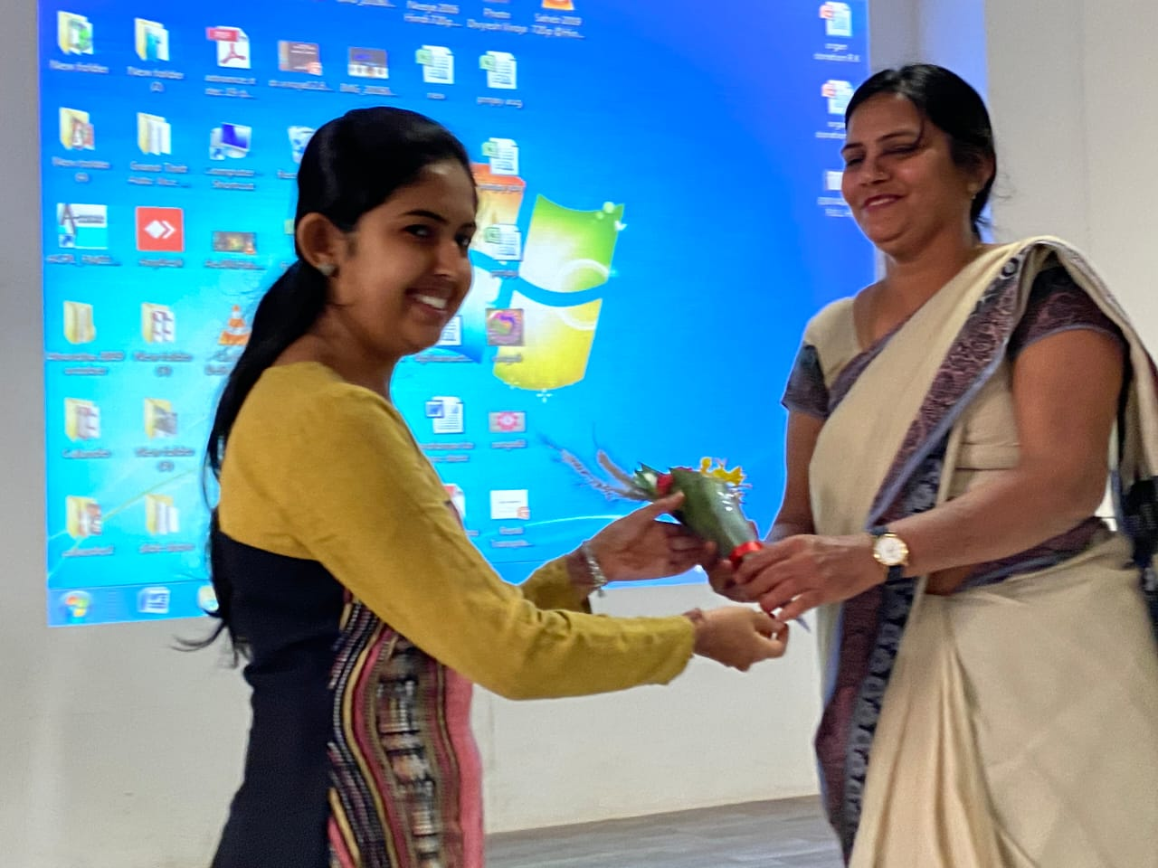

Expert session on an Importance of an Organ Donation by Dr. Divyesh Viroja

Expert session on When to Do Organ Donation by Dr. Sankalp Vanzara

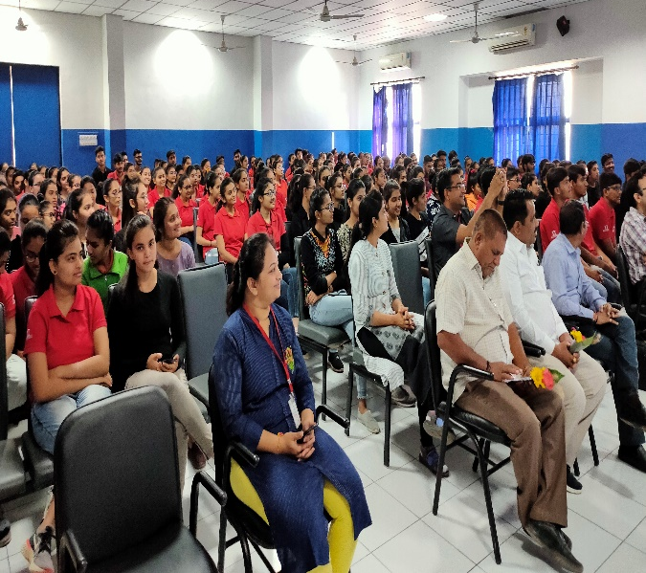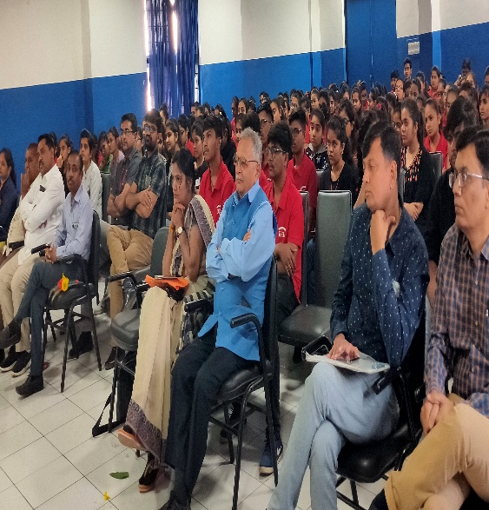

Vote of Thank to SPT, RK University by Dr. Pradeep Kansagra

Facilitation of an Organ donor Ravindrabhai Bosamiya and his wife Jyotsanaben Bosamiya by Bhavnaben Mandali
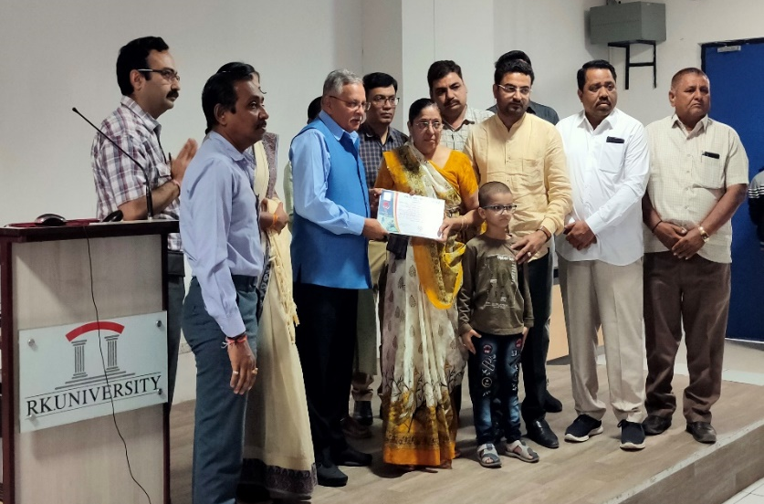

Pledge for Organ Donation

